4/5/2018

Jeff Borus, Gerry Van Etten, and Jake Werber

Section 1 Group 7

United States Navy and Kaizen/Kaizen Teams

OMIS: 442

Table of Contents

Executive Summary 2

Introduction 2

Methods 2

Results 2

Discussion 2

Introduction 3

History 3

Problem 4

Solution 5

Method 6

Aston University￼ 6

Results 8

Background 8

The Interview 9

After Care 11

Discussion 12

Evaluation 12

Strength of Implementation 12

Weakness of Implementation 13

Future Plans 15

Lessons Learned 16

Appendix A 17

References 25

# Executive Summary

It is the intention of the team to delve into how the United States Navy, specifically the Naval Aviation Enterprise initiated its process improvement program, Airspeed program. Due to the magnitude of the program we have selected to see how specifically they utilize the Kaizen tools and methodologies. During our research we will be reaching out and speaking with a Naval Aviation Enterprise certified Green Belt Certified Green Belt Aircrew Survival Equipmentman First Class Petty Officer James Wilson. Petty Officer Wilson is currently the Strike Fighter Squadron 27 (VFA-27) Aircrew Personal/Protective/Survival Equipment work center (13A) Leading Petty Officer.

## Introduction

In the introduction the team delves into the background of the Navy, specifically Naval Aviation. We then portray some of the problems that started to face Naval Aviation and how they implemented their own brand of Lean Six Sigma to combat these threats. The team focuses its efforts on looking into how the Navy specifically uses the Kaizen methodology.

## Methods

Typing some things to take up space to create executive summary outline spine Typing some things to take up space to create the executive summary spine. Typing some things to take up space to create the executive summary spine. Typing some things to take up space to create the executive summary spine. Typing some things to take up space to create the executive summary spine.

## Results

After several Skype and Facebook messenger conversations Mr. Borus was finally able to complete the questionnaire (Appendix A) with Petty Officer Wilson. In the interview the two converse about events that Petty Officer Wilson conducted with AIMD Bahrain, and how he utilizes the tools brought on by Kaizen.

## Discussion

The team evaluates the strengths and weaknesses in the Navy’s implantation of its AIRSpeed program and how that affects Kaizen methodologies. We also share recommendations with Petty Officer Wilson, his near future plans for his improvements and lessons the team has learned around the way.

# Introduction

## History

Since its inception in 1775, the United States Department of the Navy (DON) has been committed to higher standards of perfection. The mission of the DON is to “maintain, train and equip combat-ready naval forces capable of winning wars, deterring aggression and maintaining freedom of the seas” (Navy). Given a mission like this, one can see that Navy operations brings a consistent danger to service members as well as equipment. Nowhere can this be more apparent than in naval aviation.

Naval aviation first started in 1910 with the first successful launch of an aircraft off a ship. Within the next twelve years, the DON would commission its first aircraft carrier and grow to a force of over 35,000 enlisted service members and officers as well as 2,000 aircrafts. It was this force’s mission to support naval forces by being the over-the-horizon surveillance equipment, conduct antisubmarine warfare, provide support during amphibious assaults, provide logistical support, and conduct search and rescue operations. This mission would be tremendously tested during World War II where naval aviation was critical in the Battle of Coral Sea, the Battle of Midway, and the Battle of Guadalcanal, three of the most infamous battles of naval aviation. For example, the Battle of Coral Sea was the first sea battle to occur with two ships remaining out of visible range of each other for the duration of the aircraft battle, with the ships never firing at each other.

While the DON and naval aviation missions might remain the same, how the objectives are executed continues to evolve in more recent years. Naval aviation has grown more than 100,000 enlisted and officers assigned across 11 aircraft carriers, 10 carrier wings, 25 stations and 168 squadrons (Navy). Aircraft carriers carry approximately 5,000 service members each, with teams or groups of service members making up the various carrier wings aboard the aircraft carriers. Naval stations are located across the United States and in many countries around the world, with squadrons made up of planes manned and supported by enlisted service members and officers based on land at military stations or at sea on aircraft carriers.

Today, naval aviation makes up one third of the United States Navy, making it the second largest air force (Navy). Along with this growth in size, technology has changed as well. The use of a propeller driven aircraft has become obsolete as jet engines that can reach speeds of over 1,000 miles per hour power aircrafts today. Added to this is how complicated and technical carrier operations have become. Gone are the days when aircraft had to take off by their own power. Now, aircraft can be catapulted off the deck of the ship, reaching take off speeds in a matter of seconds. This same system also affects the landing of the aircraft. When coming in for a landing on modern carriers, aircraft must deploy a hook and aim their craft so as to catch a cable across the top of the carrier ship, which then aids in bringing an aircraft traveling over 100 miles per hour to a complete stop in two seconds. It is hard to see the DON as a corporation with its unique operations and lack of specific product or service. However, the Naval Aviation Enterprise (NAE) views the level of readiness that the fleet can react to as their product. Ready for issue (RFI) rates, as well as aircraft being rated as mission capable, are how the NAE measures its “net profit”. Given the level of technicality and the level of risk involved, excellence is what is expected out of naval aviation, but what about when this is challenged?

## Problem

During the late 1980’s and early 1990’s, the DON faced two growing issues. The first was a continuing decline of available resources and the second was that Naval Aviation faced a rapidly aging fleet of aircraft. Each issue on its own posed a crippling issue for the DON. The aging aircraft could and would change status from combat ready to non-mission capable constantly. A limited availability of mission capable aircraft could drastically impact the ability of the DON to perform its mission and objectives. With dwindling resources, it became difficult to prolong the life of this equipment while waiting for new replacement units to be developed.

## Solution

Using the readiness of the fleet as the product, the DON set out to meet the new age problems it faced. Naval Aviation confronted these problems with Naval Aviation Systems Command (NAVAIR) introducing the continuous process improvement methodologies of Lean, Theory of Constraints (TOC), and Six Sigma at the most in depth maintenance level in 1999 (Williams, 2007). Under the moniker of AIRSpeed, the intent was to provide better products to the Fleet not only faster but at reduced costs as well.

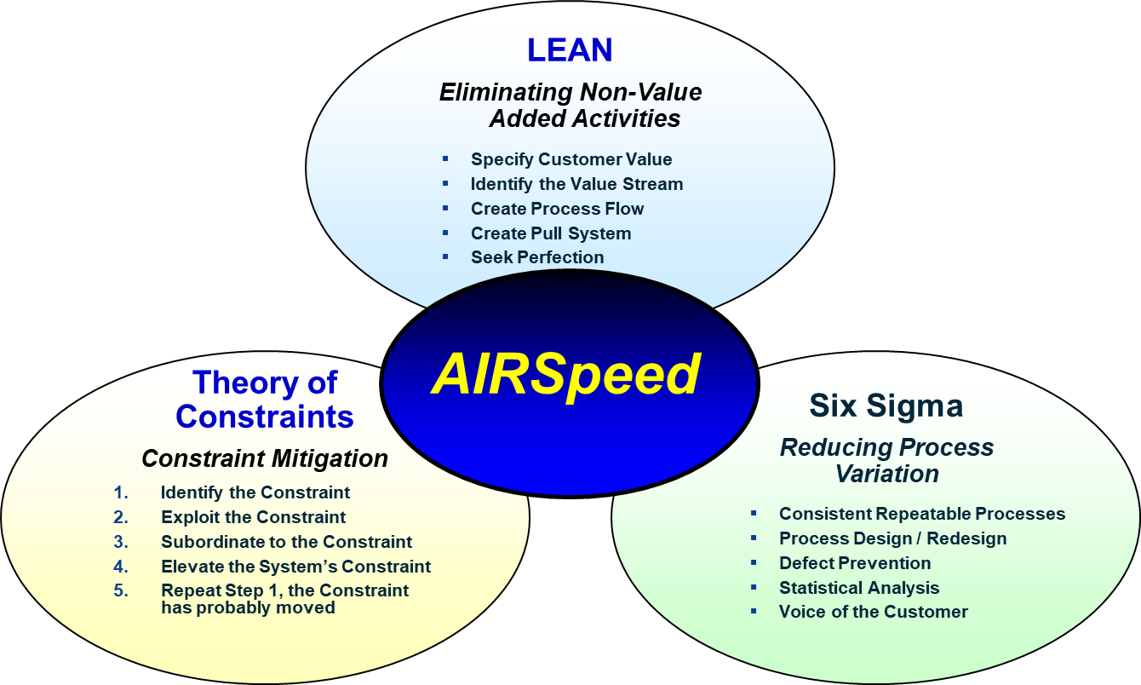

Figure : AIRSpeed program make-up

Using AIRSpeed programs, the goal is to “provide the right amount of readiness at the right cost” (Shrout, 2006). The AIRSpeed programs would face significant barriers that would arise including leadership, organization culture, organizational structure, and policies. While the program of AIRSpeed might contain a variety of tools and methodology, none more exemplifies how the Navy has used the program than the Kaizen/Kaizen Blitz approach. Kaizen is the Japanese word used for continuous improvement (McCarty, 2005), making more of a mindset than a program. Kaizen Blitz on the other hand took the concept and melded it with small high intensity cross-functional teams working towards incremental and systemic changes. Kaizen has easily been the foundation of many quality efforts in Japan including but not limited to Total Quality Management and Quality Circles. Taking this small team approach the DON is able to be more flexible in their application of other process improvement methodologies.

# Method

## Kaizen

What is Kaizen? Kaizen is Japanese it stands for "Kai" which stands for "change" and "zen" which stands for "for the good". Matuvosa (2016) says that kaizen is "The strategy where employees at all levels of a company work together proactively to achieve incremental and regular improvements to the working process". Simply put it means that the company uses talents from all departments to create a team that is based on improvement. Another definition for kaizen event by Cavazos-Arroyo, J. Et al. (2018) is "A Kaizen event is a project focused on structured improvement (an interdisciplinary team is dedicated to improve specific work areas, with defined goals, in an accelerated timeframe (<1 week-)), characterized by several traits, including a low capital investment, an orientation to action and autonomy, and an application of tools for the establishment of quality and process analyses ". It started in Japan after WWII to improve their workforce and improve their companies. Kaizen focusses on improving almost everything, some of the ones that stood out to me where increase product of quality, improvement of materials handling, improving working conditions, and waste reduction and standard time. There are six steps in the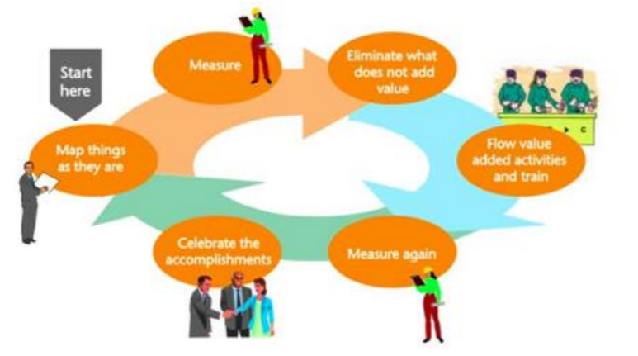 kaizen process (see figure 1) these steps help the team use the kaizen process to improve whatever they need in an easy step by step process. Kaizen is usually used in the six-sigma process because without six-sigma kaizen wouldn’t be able to fix everything. Mativosa (2016) explains six-sigma as "Six Sigma is a way of thinking and the results of the approach can yield a spectrum of improvement choices based on the balance of value and risk."

When companies say the used kaizen what they really did was implement kaizen events. A kaizen event explained by Eileen M. Van, A. et al (2010) "where short‐term improvement projects (Kaizen events) are systematically used to introduce rapid change in targeted work areas, often relying on lean work system principles." Kaizen can be used in more than just the private sector in can also be used in the public sector. The air force is a huge user of kaizen events to improve multiple aspects. When using the kaizen events, they often must rely on lean work system principles. According to Phoewhawm, R. (2017) you use routers when "Kaizen events take flight when there is a dedicated cross-functional team that is focused on ways to improve a targeted work area, with specific goals, in an accelerated timeframe". What the air force was looking for while using the kaizen events described by Eileen M. Van, A. et al (2010) are "clearly defining event goals, scheduling extended follow‐up activities, defining measures to track results, assigning roles for Kaizen event evaluation activities, and sharing lessons learned in areas of the organization outside the work processes". As you can see using kaizen events can help companies and organization can them figure out what they need to do to improve themselves.

Many companies use the kaizen process to help improve their company including electronics, aeronautical, and many more. A manufacturing company in Ciudad Juarez, Chihuahua is one of those companies that used kaizen to try and help improve the company. For this company kaizen changed the workers mentality of work. The first thing was to positively influence workers attitude during the job, the second one is to positively influence workers motivation, the third is positive influence on the work are impact, the fourth is employee attitude towards work influences motivation, and the final one is motivation affects the work area in a positive manner. Cavazos-Arroyo, J. Et al. (2018) concluded that "Kaizen culture generates a positive change in employees’ attitudes.". So, by looking at this you can tell that kaizen can be used for many more things then what I stated above.

**Printing Industry**

Kaizen is one of the biggest tools used when trying to improve a company because you can use it in any company and in almost any situation. For example, a printing company had a productivity problem and they decided to use a kaizen event to fix it. They ran two kaizen events in these two events they and Chan, C. O., & Tay, H. L. (2018) said they used three items to help find the problem they "are line balancing, standardized work, and standardized layout". The results of the kaizen events are where a 10-30 percent improvement in the assembly area.

## Aston University

Kaizen is an approach that can be utilized in many different types of settings, including the academics. In the United Kingdom, Aston University is dipping its toes into the implementation of Kaizen in its long-term planning process. The school was compelled to search for a more quality driven approach due to the financial constraints placed on UK universities back in the 1980's, with funds being reduced by 30% (Clayton 593). So, they embarked on a 15-year restructuring program with some key elements. These elements are academic restructuring, corporate identity, physical restructuring, advanced academic support services/ focus on customer care, and the ability to attract and retain high caliber staff and students (Clayton 593). Due to the financial cuts, the student population was decreasing at a rapid rate and staffing at the university was down to half of its previous level. Aston's response to this was to focus on recruiting staff that were highly talented at what they did to make up for the lower numbers (Clayton 594).

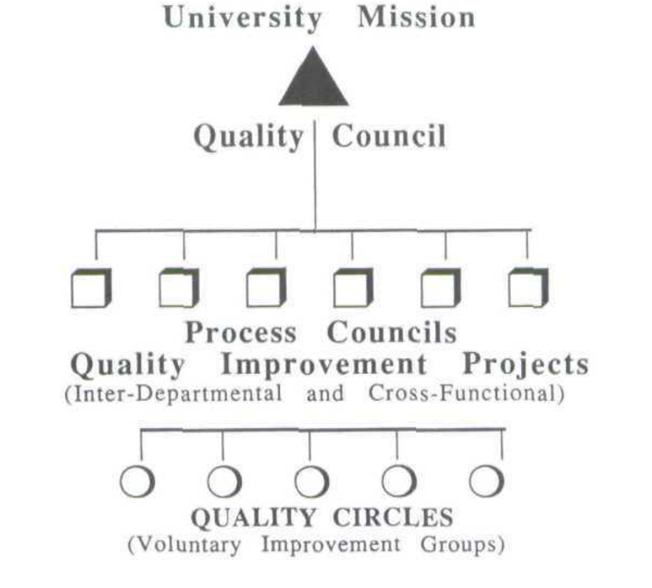[UGC Structure]

As the school began experimenting with the kaizen approach, they formed the University Quality Council (UQC), which would meet in five-week intervals. To start out, the council needed to analyze the top-level processes of Asten that are necessary to meet its mission as a university. Such as providing their students a complete education experience and promoting research activity (Clayton 597). The council then had its individual members each take responsibility for one or more of those processes, focusing on bringing about improvements. When analysis has been done, sometimes there might be a team that gets put to work on a quality improvement project. These projects are intended to be "systematic as well as pragmatic in isolating significant, but manageable, areas amenable to improvement by the QIP in a reasonable time-scale" (Clayton 597). Aston university will look to fine tune the way they go about quality improvement into the future, with Kaizen likely playing a major role.

**Nursing Management**

Kaizen has made its way into Nursing Management as well. Because of the decrease of funding in healthcare, patient care must be done in a more efficient way. So, Karlene Kerfoot and Duke Rohe recommend implementing Kaizen by changing the cultural values, encouraging the staff to see themselves as owners of their unit. This could help them develop commitment to continuous improvement (Kerfoot and Rohe 228). It is also recommended that nursing unit leaders support action, initiative, and risk taking. When it comes to processes, they need to be examined to discover new efficiencies that can be incorporated. The biggest time wasters get identified so tests can be done to adopt newer, more efficient processes (Kerfoot and Rohe 228).

The authors stress a few techniques for the success of Kaizen within nursing management. First is that to make the necessary improvements, suggestions must be generated. Suggestions should be considered by staff, patients, physicians, radiologists, and so on (Kerfoot and Rohe 230). There also needs to be a system of rewarding staff who contribute suggestions in a meaningful way. When these suggestions are made, self-managing teams should have the responsibility of implementing and improving them (Kerfoot and Rohe 230).

**Childrens Medical Center**

Kiazen has been applied to laboratory operations as well. Childrens Medical Center in Dallas, a tertiary care pediatric hospital, looked to Kaizen to manage the increasing volume of specimins proccesed in their lab. They embarked on a project to test the method using preexisting tissue obtained from participants (Sugianto et al. 260). Their goal was to eliminate waste in GI biopsy processing and handling and to maximize value for their customers.

What they found as a result was a large portion of their waste was in the major waste category of waiting. Since their test requisitions would frequently sit in a bin awaiting transcription (Sugianto et al. 261). So, to eliminate that waste, they standardized the workflow so that the requisitions were transcribed on receipt by the transcriptionist (Sugianto et al. 261). They also wanted to create a continuous process flow. They accomplished that by making the specimen batches as small and manageable as they could, while facilitating a continuous workflow (Sugianto et al. 262).

**Air-conditioning Coil Manufacturing**

An investigation was undertaken at Blue Star Limited to implement Kaizen, looking improve the productivity of air-conditioning coil manufacturing. They employed it as well as using value stream mapping and single minute exchange of die (Das et al. 307). They made major design changes in the expander machine to reduce setup time by applying a gear rack and gear pinion mechanism, spring and cam and lever mechanism, and one tough mechanism within different parts of the machine (Das et al. 307). Blue Star Limited also moved to simplify the setup procedure by eliminating waste from the setup of the expander. Lastly, they reduced shop floor congestion by reducing work-in-process inventory (Das et al. 307).

**Audit in Psychotherapy**

Within the National Health Service (NHS), out-patient psychotherapy services lead to monitoring of different modules of the process of referral, assessment, and treatment. Within those services, The Maudsley Hospital was looking to monitor routinely collected data, and more complex clinical assessments (Feldman 334). The modules that were considered were referral, assessment, treatment, and follow up. Then monthly audit meetings examining information were instituted in which each module was considered in rotation. Then finally, the main part of the audit meeting is devoted to a discussion of clinical issues relating to the module (Feldman 336).

**Method – Research on the Process and Quality Improvement Topic: (15%) 6-8 pages (literature review of the topic/technique)**

Was the method section well written, including spelling and grammar?

Did they research their topic thoroughly?

Did they cite at least 10 references in this section of the paper?

Were at least 8 of the citations from academic journals with findings explained in the paper?

Did they cite articles from the list of journals provided in the course packet?

Did they provide information over and above what was presented in class?

Did they follow directions when listing and citing references (see course packet)?

Was this section interesting and informative?

# Results

## Background

When evaluating how an organization and how they utilize any process improvement tool, it is best to go straight to the source. While being stationed overseas at the Aviation Intermediate Manatee Detachment (AIMD), Mr. Borus had the pleasure of being a part of the Navy’s AIRSpeed program. As a site core team member and Lean Practitioner, it was Mr. Borus’ responsibility to conduct certification training as well as conducting and mentoring events. In the process, he met many different individuals that he helped in the implantation of lean six sigma methodologies. One such individual that Mr. Borus was able to get the pleasure of interviewing was certified Green Belt Aircrew Survival Equipmentman First Class Petty Officer James Wilson. Petty Officer Wilson is currently stationed in Iwakuni, Japan with the Strike Fighter Squadron 27 (VFA-27) as the Aircrew Personal/Protective/Survival Equipment work center (13A) Leading Petty Officer.

Due to Petty Officer Wilson being stationed in Japan and in the middle of a home of port move, Mr. Borus was able to conduct the interview over several Skype phone calls and email correspondence. While discussing more of the general ways that the military uses the tools there was one project event that Petty Officer Wilson continued to circle back to. After a recent Aviation Maintenance Inspection (AMI) AIMD Bahrain received several low marks for the processes and procedures in their aviation life support systems (ALSS) and ordinance programs. Petty Officer Wilson was one of the individual selected to go to the command and assist them in restructuring the programs up to standards.

## The Interview

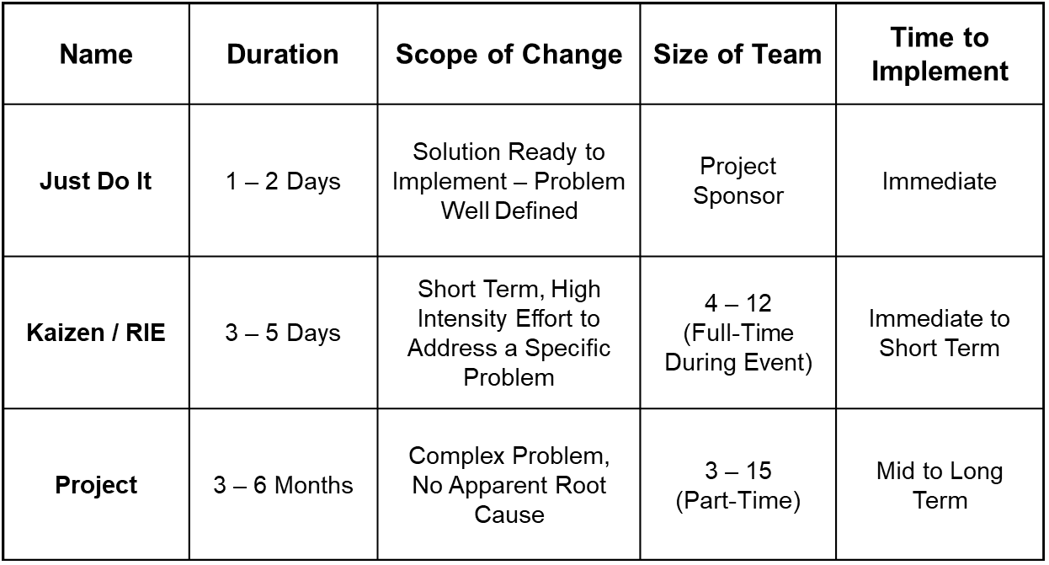When Mr. Borus first started the interview, he asked how Kaizen/Kaizen Blitz worked with the DoN. Petty Officer Wilson explained, “Honestly it’s kind of the core of everything. Kaizen is all about incremental changes brought on by small teams, which given the nature of the military that’s all you get sometimes. We always run into issues where we don’t feel like we have enough people and Kaizen kind of takes that into effect” (Wilson, 2018). Further on Petty Officer Wilson went into great detail about a series of events he had performed with AIMD Bahrain. He said, “At first we faced a lot of conflict and push back. The technicians and the leadership were just not on board for having an outside team come in and look at all their processes” (Wilson) This is something that he and the team had to work diligently at to manage. They had to work and ensure that the events would yield tangible results without going against any of the standards or regulations that governed them.

To do this they focused on creating small teams that would spend the bulk of the deployment running several Kaizen/Rapid Improvement Events (RIE) simultaneous. As a Green Belt it was Petty Officer Wilsons duty to help guide the teams as well as aiding in the management of expectations. To express this Petty Officer Wilson walked through their process. The first thing was to identify team members and which processes exactly were the ones responsible for yielding the most discrepancies. This was easily done by reading the inspection results and looking over the recorded histogram of most occurring discrepancies. The team consisted of four individuals outside of AIMD Bahrain and four attached, keeping inside to outside eyes even. After this was the first obstacle for the teams, mapping the processes out. “We faced the challenge of getting the workers to be direct and truthful with us. Everything in aviation is processed out but we don’t always follow them like we should. Getting the technicians to admit this and give us an accurate map was difficult, but we eventually got them talking” (Wilson, 2018). From there they had over looked the process map to see what controls they could put in place to limit discrepancies and changes they could make to improve the flow. It was at this point that Petty Officer Wilson admitted to getting some buy in as the changes were starting to come from the workers. He explained how some excitement started to rise out of them at the chance to change things that had been a pester to them in the past. And with this the team released their first set of “just do it” (JDI) improvements out of the event.

It was at this point a few days into the deployment that people started to take note of the gains. Reduction of process time and immediate defects were apparent within three cycles after the improvement. Seeing this the team was approached by others within the command looking to see if events could be conducted there as well. However, given the fact that the time line for all the events was only a period of ten days there was no way to complete them all. “We wound up just focusing on giving some training to the command. Its wasn’t very advanced training, I think it was a modified version of the Yellow Belt course, but it was better than what they had before we got there” (Wilson, 2018). The training mainly consisted of Kaizen, Lean, TOC methods and a few basic quality tools.

## After Care

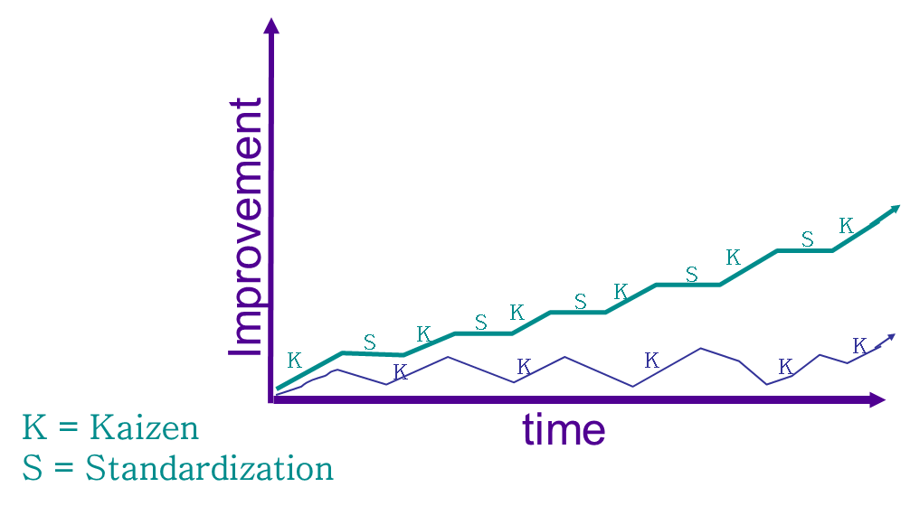 Before the completion of the interview Petty Officer Wilson had started to discuss how the follow up of any improvement event or action is arguably the most critical. The AIRSpeed program adopts the DMAIC model used in Six Sigma and as such is composed of the control phase of an event. In conversation he said, “there are so many times that I run a small event on to and make some new changes only to have them completely thrown to the side when I go on leave” (Wilson, 2018). The simple differentiation that the military uses the DMAIC model with all process improvement events regardless of the type helps to ensures that improvements can last. Before the end of any event one of the main deliverable of the events are detailed control plans and actions to prevent slip back.

It is here that Petty Officer Wilson did voice some concern about the events conducted at AIMD Bahrain. “After paying all of the money to send all of us TAD there I really hope that they can keep with the program. It’s always sad when processes revert to old ways but so much more when there is already money being put into the event” (Wilson, 2018). Even though the command by the end of the deployment seemed on board with the new improvements and running future events that does not always match what will happen. As discussed, the lack of good controls could forfeit all benefits of conducting an event. In closing of the interview we asked one last question to Petty Officer Wilson, if he felt that Kaizen events were just a substitute for daily improvement? After a moment to think he responded with, “no, I think they are beneficial, but you will see better improvements in the day to day. For this training is critical so people can see the underlying issues, the changes, and the results of improvements. Just because we can run a multiday event to make changes doesn’t mean that we should. I tell my guys all the time if you see something that’s wrong or a way it can be better do it, and if any one tells you otherwise come get me and I’ll handle it.” (Wilson)

# Discussion

## Evaluation

After looking into the program and talking with Petty Officer Wilson we believe that we can conduct an analysis of the AIRSpeed program, specifically how they focus on Kaizen.

## Strength of Implementation

Perhaps the biggest strength in the implementation of an improvement program or methodology like these is the organizational structure. The military is more rigid than a normal corporation in the sense that there are no deviations. Whereas employees that do not meet goals might lose their positions, service members will do whatever it takes to meet the order. This means that the programs will be implemented to at least the most basic of standards. Although this might seem like a weakness it is not. One of the standards is training to be conducted through NAE commands. All service members are minimally trained as Yellow Belts and commands are responsible for maintaining core competency with Green Belts and Black Belts. Even at the most basic a minimal level Kaizen can be an extremely powerful tool for process improvement.

The standards also set up another unique strength that the military has. Due to the makeup of the military, failure to achieve standards face greater levels of consequences than they do in the corporate arena. And as Kaizen is a robust methodology that focuses on changes over time versus sudden changes, this means even minimal effort could be better than nothing. Doing a complex Lean or Six Sigma event might have a detailed list of deliverables to be met and need controls to prevent backslide. With Kaizen, which can be used with and during other improvement events, the changes are implemented before the end of the event and generally are small enough not to need detailed controls.

The last large strength behind the program is the communication of events. The DON uses their own Continuous Process Improvement Management System (CPIMS) to act as a repository of events conducted within the Don. This is a fantastic way of sharing best practices across the fleets, as well as to see what major events might be replicated or even improved upon. It also acts as a way of streamlining certification of personnel. Instead of having Master Black Belts traveling around the globe to check progress they can view the deliverables through the site, saving not only time but also travel costs.

## Weakness of Implementation

The largest weakness of the military adopting an improvement program like this would be the cultural by in from service members. The military much like any large long-standing organization is built on traditions. There are many people that have dedicated years in their craft, as such they harbor resentment for changes. Being able to manage event expectations and showing improvements early is really the only way to combat this culture as it is more difficult in the military to rotate leadership.

This is also coupled with the fact that the AIRSpeed program is almost entirely internal to the military. No longer are outside consultants brought in to spot check areas of the program. This lack of oversight could create a stagnant environment, preventing the future improvement events from flourishing. One of the largest issues with process improvement is the ability to take a step back and see the process. Therefore, during Kaizen event a cross-functional teams are key. It will be the people that do not do the work every day bringing questions to bear to counter the “that’s the way we have always done it” mentality.

Another weakness of the military’s program as a whole is the breath that it covers. The DON conducts operations all around the globe making it difficult to share ideas across platforms. Even the DON uses the CPIMS site to share knowledge the simple fact is that not everything is sharable. While you might be able to see the tools and process that a team had used you can miss the context and reasoning behind certain decisions made. This could either stop potential events before they get started or extend the timeline of the event while teams try to get correspondence from the other side of the world. There also is the fact that not all site’s have full access to the site or go on routinely to view and see if there is anything new.

Perhaps the largest weakness of their implementation strategy is the limitedness of the roll out. Currently it is only the aviation departments of the DON that uses this program. There are plans in spreading the effect of the program or creating sister programs to run in tandem for other operations. This could be a large problem in the future as the standards set by the NAE program might not match those created by the other departments of the DON. Anytime that there are differing standards or procedures there is a higher risk of variation slipping into the program. Overtime these variations might breath in problems and conflict across different teams, causing more conflict.

**Recommendations**

While conversating with Petty Officer Wilson we had talked about different things that he might like to change about the program as a whole or even just his small section of it. One such change was a more stringent training regimen in the methodologies. As it stands only the most basic and watered-down training is required to give awareness. But awareness is not always good enough, “I think that going to the Green Belt level should be a requirement, getting people to use these tools in the day to day grind is the only other way that larger changes are going to be seen” (Wilson, 2018). Petty Officer Wilson was very open to new training ideas discussed such as miniature simulations and even attempting to develop some type of drill to ensure his personnel could identify something that they had authority to fix on their own or something an event would be needed for.

One other recommendation we had made to Petty Officer Wilson was more regularly checking the CPIMS. Through regular screening of the database he could get a better feel for what events might be out there that even he did not see. This would not only help him maintain an outside perspective but also revitalize him when he starts to feel himself defaulting to that “the way we have always done it” attitude.

Another recommendation would be to push to implement programs within the military to better understand what the culture is like and how to deal with the people within another country so that things go smoothly. Also, to implement programs to improve the cohesiveness within the military, improving the internal culture. It is better to take action before, so operations go more smoothly and missions can be more efficient.

## Future Plans

Taking the recommendation of more frequent, consistent training, as well as simulations was something that Petty Officer Wilson was going to start working on implementing. He had also agreed that looking into CPIMS more often would be highly beneficial. The hard part of the matter is his position is one where he cannot affect large scale changes. “Sure, I can make changes to my shop, but that doesn’t mean that any other shop or department will change as well.” (Wilson, 2018). This also means that downstream communication about the large direction of the program is not always disseminated down through the ranks. Yes, the information is sent out to the site core teams, but they are not always the best at further disseminating that information.

## Lessons Learned

Perhaps the largest lesson learned during the project is time and personnel management. This not only shows for the project itself, but also while using Kaizen. While on event there are many different moving parts and keeping the team on task can be difficult. This is even more so when you also factor in the short time, high intensity nature that comes with Kaizen events. Another related key take away is the constant management of expectations between the process owners and the teams conducting the event. A team must work hard to establish trust and gain buy in from the process owners, and once you obtain it things only get harder as you must then strive to match and surpass it.

# Appendix A

**Interview Questions and Responses**

1. How does Kaizen/Kaizen Blitz work with the military?
   1. Honestly, it’s kind of the core of everything. Kaizen is all about incremental changes brought on by small teams, which given the nature of the military that’s all you get sometimes. We always run into issues where we don’t feel like we have enough people and Kaizen kind of takes that into effect.
2. What was the journey like to achieve your certification?
   1. It was a fun time to learn and apply the processes. Identifying what could be changed and how was interesting but the largest challenges, buy in from the people.
3. Is there a specific kaizen event that sticks out to you?
   1. I went on deployment to AIMD Bahrain to assist the command aviation life support systems (ALSS) and ordinance programs redesign due to inspection failure. It was hard at first because no one wanted to give assistance or information on how things were run. But after knocking out a few quick improvements people started to come on board to the ideas and contributing.
4. While conducting an event what was the largest barrier that you faced?
   1. Information of the specific job and buy in from the personnel are about tied. If they don’t believe in the event they either will not help you or not conduct the job like they normally would. This of course gives us a false view of the current process and leads us to making false conclusions. Its funny how those two filters back into one another like that.
5. What was the culture of the organization both before and after the event/training?
   1. Before the command was hard to work with, as is to be understood after getting such remarks on a major inspection. But as I said once some of the changes started to show results people came around. We were contacted by other work centers wanting to perform events. Due to time constraints the best we could really do was conduct some training on the basic tools, so they could implement the corrective actions for themselves. People tend to accept the changes better if they are the ones making the changes.
6. How did you manage the clash of cultures?
   1. Patience, that’s biggest key. At the end of the day the navy isn’t like a business, the CO says it’s going to happen and it’s going to happen. But that doesn’t mean people will always do it ungrudgingly. But after walking through slowly and showing people eyes started to be opened.
7. Since changing commands have you noticed different improvement opportunities and started your own event?
   1. Going from Misawa where I learned the tools to boot camp and now VFA my roles have changed. In Great Lakes I had worked as an external customer for an event performed in Recruit Training Command Greatlakes for an event in issuing the recruits clothes and personal supplies. And when I got onboard at VFA-27 I instantly started to change the set up and layout of the shop to include better flow. This not only wound up giving us open sightlines, but it also allowed access to the gear giving the piolets and technicians a ease and efficiency to don the gear and correct discrepancies.
8. How do you measure quality in the military?
   1. To me it’s measured by the number of re-work we do. If we don’t have re-work were doing a quality job. Time is the other factor, in the military speed is critical and we have to work to keep those down.
9. Do you use the creative problem-solving technique? If you do when do you use it?
   1. We kind of use this technique in certain departments. When the navy issue technical directive changes they use this method in finding all of the information and rolling out the corrective packages. Personally, I tend to use the DMAIC model.
10. How often do you use one of the tools in the magnificent seven?
    1. After getting my Green Belt I saw how we could use some of the tools. As a LPO I use check sheets on an almost daily basis for making sure that I keep the shop on issue and don’t veer off. We also use scatter plots and cause and effect diagrams in the shops themselves to make sure that people are aiming at actual fixes. We even have a few fishbones for common discrepancies for quick turnaround.
11. Do you use PDCA or FADE in the organization?
    1. I do use the PDCA model for training. It’s how we structure things for younger sailors so they can get a feel for how to build a training lecture or module.
12. Besides Kaizen do you use any other methods?
    1. Not really. Given the nature of the squadron we have to keep things really small. We end up looking at a lot of different process and do a quick process map and fishbone. From there we focus on the quick JDI (just do it) fixes. Helps keep the teams small and fast turn arounds, plus when we have more time we can always go back and re-evaluate the map.
13. How often do you use the three levels of mistake-proofing?
    1. I say about half of the time. Given the nature of the ALSS program though sometimes we have to try a new process out to see if it will yield an error before we make it so one cannot be inputted.
14. Does the military use 6-sigma tools?
    1. Yes, but mainly at the higher levels. There probably could be some 6 sigma events that I am overlooking but right now we just don’t have the capacity to devote to it.
15. Do you know of any examples of the military using the poke-yoke strategy of mistake proofing?
    1. We tend to use a lot of shadow boarding and parking lot spaces for quick inventory. In Misawa our landing bay door techs used pre-made drill plates to ensure we were drilling the proper sized holes in the proper places for the aircraft. It was a bad day when you went to go install the door and found out you had too big of a bolt or extra holes. The plates allowed us to really cut down on costs and time.
16. How important is a shared vision?
    1. Extremely, people get set in their ways and if they aren’t seeing an improvement they just shut down. This happens more so in the higher ranks of the military, you just get to a point you stop thinking about new ways of doing things or think that your fifteen plus years of experience cant be trumped.
17. What are some examples of past quality defects that you’ve experienced get fixed?
    1. We kept running into issues with proper inspection processes where we would receive and accept gear that was not properly done, creating double work for us. So we created a flowchart and a check sheet to aid the people to ensure that a proper inspection was conducted and parts were accounted for.
18. What do you believe is the optimal way to use 6-sigma in the military?
    1. I think before you think about using the tool you have to first focus on training. I think that going to the Green Belt level should be a requirement. Getting people to use these tools in the day to day grind is the only other way that larger changes are going to be seen. After this I think how we use it with the more in-depth analysis’s being conducted at the higher maintenance levels. It would be nice to see wider spread certification though.
19. Are there any other certifications you are interested in pursuing in the future?
    1. I have looked into getting my Black Belt, but with deployment and other things that I have going on I have not had time to further pursue but do intend to after service.
20. If you had the chance to do it again, would you join the military?
    1. Yes, just for the experience and the things that you learn. I would have never been exposed to CPI if it were not for the military.
21. Do you use any quality control tools such as flowcharts, check sheets, pareto charts etc.?
    1. As I said I use flowcharts, and check sheets all the time.
22. If so which of these tools do you prefer most?
    1. I do a lot of mental flowcharts just to give me a reference for making small improvements. I also try and get junior sailors involved and have them learn to use the tools. Doing it this way also helps cause in my current position I am removed from some of the work, but this does give the junior sailors the authority to make the changes because ultimately, it’s my call.
23. Do you use affinity diagrams for identifying patterns?
    1. Yes. We more so using it for mapping out brainstorming ideas which help us to map it out before implementing the changes.
24. What corrective action do you take when there is a flaw in quality?
    1. First, we have to identify the flaw which can be a problem in itself sometimes. After that we work backwards to see where the defect first occurs. Most times it’s a quick JDI and we make the change and evaluate to make sure that fixed everything. If not we go back and look at deeper issues such as training.
25. What areas of the military have room for improvement with quality?
    1. Contracts with exterior companies. Right now, most of them seem so vaguely written and just allows way too much variation. This is bad when we get on a fixed timeline. Most of the time rather than holding the contractors accountable to their contracts we have to end up pushing things back which causes horrible delays and rework.
26. In your opinion, does quality play a major role in military operations?
    1. Yes. A lot of the military processes are fairly repetitive and so we find ourselves doing a lot of duplicate work. If you add in quality problems such as defects you very quickly end up wasting manhours that could be focused on other aspects of the mission.
27. What role does ethics play in the military?
    1. Ethics is very important role, but on a fine line. There are many different people in the military, so ethics can very easily become blurred. I think that’s why large organizations such as the Navy creates their own core values to try and keep us all together and on track.
28. How do you reward ethical behavior and dissuade unethical behavior?
    1. Well really the only way we can most of the time, liberties. If you do not follow the ethical guidelines in place you face having certain liberties away. That’s one of the biggest difference in the military.
29. How long do your events normally last?
    1. In Bahrain the event lasted about eight days which is why we focused on multiple small JDI’s that we can get done in three days or less. But at the same time we gave training on the tools used so hopefully the command will start going back and doing more in depth events.
30. Are Kaizen Events a Substitute for Daily Improvement?
    1. No, I think they are beneficial, but you will see better improvements in the day to day. For this training is critical so people can see the underlying issues, the changes, and the results of improvements. Just because we can run a multiday event to make changes doesn’t mean that we should. I tell my guys all the time if you see something that’s wrong or a way it can be better do it, and if any one tells you otherwise come get me and I’ll handle it.
31. How do you track and record your completed event and improvements?
    1. We use CPIMS to store all the events in the past and present.
32. How often do you go on and check for new event ideas?
    1. Honestly not nearly as often as I probably should. I think right now I might log on once a quarter because every time I do I have to reset my password.

# References

Awad, M., & Shanshal, Y. A. (2017). Utilizing Kaizen process and DFSS methodology for new product development. *International Journal Of Quality & Reliability Management*, *34*(3), 378-394. doi:10.1108/IJQRM-09-2014-0139

Bar, D., Russell, J., & Finamore, L. (2006). Department of the Navy Lean Six Sigma: A Financial Journey. *Armed Forces Comptroller*, *51*(1), 38-41.

Cavazos-Arroyo, J., Máynez-Guaderrama, A., & Valles-Monge, L. (2018). Kaizen events: an assessment of their impact on the socio-technical system of a Mexican company. *Ingeniería Y Universidad*, *22*(1), 1-16.

Chan, C. O., & Tay, H. L. (2018). Combining lean tools application in kaizen: a field study on the printing industry. *International Journal Of Productivity & Performance Management*, *67*(1), 45-65. doi:10.1108/IJPPM-09-2016-0197

Cheng, L. J. (2018). Implementing Six Sigma within Kaizen events, the experience of AIDC in Taiwan. *TQM Journal*, *30*(1), 43-53. doi:10.1108/TQM-02-2017-0017

Das, Biman, et al. “Applying Lean Manufacturing System to Improving Productivity of Airconditioning Coil Manufacturing.” *The International Journal of Advanced Manufacturing Technology*, 2014, doi:10.1007/s00170-013-5407-x.

Eileen M. Van, A., Jennifer A., F., Wiljeana J., G., & Geert, L. (2010). A framework for designing, managing, and improving Kaizen event programs. *International Journal Of Productivity & Performance Management*, *59*(7), 641-667.

Matusova, D. (2016). THE IMPROVEMENT OF LOGISTICS PROCESSES THROUGH KAIZEN AND SIX SIGMA. *Transport & Logistics*, *16*(38/39), 1-6.

McCarty, T., Daniels, L., Bremer, M., & Gupta, P. (2005). *The Six Sigma Black Belt Handbook*. McGraw-Hill

Navy Mission Statement. Navy. Retrieved from <https://www.navy.com/about/mission.html>

Phoewhawm, R. (2017). Aspects of learning performance as a cross-functional team in a Kaizen-led working environment. *UTCC International Journal Of Business & Economics*, *9*(2), 77-94.

Shrout, G. (2006). Naval Aviation Enterprise. Retrieved October 19, 2006, 2006, from

<http://www.cnaf.navy.mil/nae>.

Sugianto, Jessica Z., et al. “Applying the Principles of Lean Production to Gastrointestinal Biopsy Handling: From the Factory Floor to the Anatomic Pathology Laboratory.” *Laboratory Medicine*, vol. 46, no. 3, 2015, pp. 259–264., doi:10.1309/lmjcufun0lt8c6db.

Williams, R. (2007). Naval Postgraduate School Thesis. Retrieved from <http://www.dtic.mil/dtic/tr/fulltext/u2/a473593.pdf>

Wilson, J. (2018, April 30). Phone interview.